Lesson plan 3: Macros
About the lesson
This lesson teaches students how to use macros to automate actions within a spreadsheet. They will learn how to record macros and how to link the macro to a button so that it can be run on demand. They will then apply this learning to practical activities using the spreadsheets provided.
Learning objectives
By the end of this lesson, students will be able to:
- be able to record macros and assign them to a button on a spreadsheet
- know how to view the macro code
- have developed a macro to reset values in a spreadsheet.
National Curriculum
The following subject content from the KS3 National Curriculum is included in this lesson:
- Design, use and evaluate computational abstractions that model the state and behaviour of real-world problems and physical systems
- Understand the hardware and software components that make up computer systems
- Use two or more programming languages, at least one of which is textual, to solve a variety of computational problems
Links
The activities related to editing Visual Basic or JavaScript in this lesson links to the Python programming units, and should extend students’ appreciation the range of high-level programming languages used in many applications.
Key terminology
macro, Visual Basic, JavaScript, button
Teaching and learning activities
Share the objectives for the lesson with students (Slide 2 of Lesson 3 presentation).
Starter
Show students an image of a robot (Slide 3).
Ask: What are robots used for?
Example responses may include: manufacturing, assembly and packing, space exploration.
Ask: Why do we use robots to produce goods?
Example responses: They are quicker than humans; they are more accurate than humans; they don’t get bored.
Explain that robots are often used to complete tasks that need to be repeated over and over again because they can be programmed to do things quickly and in exactly the same way every time.
Part 1
Explain that it is possible to create macros in spreadsheets to automate routine tasks (Slide 4 (Excel) or Slide 5 (Google Sheets) and page 82).
Ask: Can you work out what any of this code does?
Slide 4
- Sub ClearSheet() is defining a subroutine called ClearSheet.
- ClearSheet Macro, shown in green, is a comment explaining what the macro does. This is inserted automatically, based on the macro's name.
- Range("M10").Select selects a range which, in this example, is simply cell M10.
- Selection.ClearContents clears the contents of the cells in the range.
- The program continues with lines of code that select a range of cells and delete the contents of those cells.
Slide 5
- function ClearSheet() is defining a function called ClearSheet.
- var spreadsheet = SpreadsheetApp.getActive(); gets the active sheet in a spreadsheet.
- spreadsheet.getRange('B8').activate();selects a range which, in this example, is simply cell B8.
- spreadsheet.getCurrentCell().SetValue('FALSE'); sets the value of the check box in the current cell to False.
- spreadsheet.getActiveRangeList().clear(); clears the contents of the list of active ranges.
- contentsOnly: true only clears the contents, it does not clear the format or data validation rules.
- skipFilteredRows: true ensures that the filtered rows are not cleared.
Demonstrate how to record a macro (Slide 6 plus Video 3.1 (Excel) or Slide 7 plus Video 3.1 (Google Sheets) and page 82).
Demonstrate how to create a button and assign a macro (Slide 8 plus Video 3.2 (Excel) or Slide 9 plus Video 3.2 (Google Sheets), and page 82).
Ask students to complete Activity 3.1: Pizza orders (Part 3).

Common misconceptions
Students will often just re-set the values of any check boxes that are currently selected, and will not appreciate that all check boxes need to be cleared when the macro is run. Remind students that every check box should be set to unselected when the macro is recorded.
- Students should develop the spreadsheet they created in Lesson 2 and the instructions for this activity are on Slide 10 (Excel) and Slide 11 (Google Sheets). Students who have not completed the activities in Lesson 2 can use Excel workbook 3, sheet 1/Excel workbook 3.1; Google Sheets workbook 3, sheet 1/Google Sheets workbook 3.1.
- If they are working in Excel, make sure students re-save the spreadsheet they created in Lesson 2 as a macro-enabled worksheet before recording the macro.
- Check that students have recorded a macro that clears the contents of the required cells.
- Make sure that students have inserted a button and given it an appropriate name.
- Check that the correct macro has been assigned to the button.
- Encourage students to test that their macro works by populating the spreadsheet and then running the macro to check that the relevant cells are cleared.
Part 2
Explain that it is possible to edit the code of a macro to correct errors or to add extra functionality (Slides 12–14 plus Video 3.3 (Excel) or Slides 15–17 plus Video 3.3 (Google Sheets)).
Ask: What code would I need to enter to change the text colour of cell B2 to red?
Answer
Microsoft Excel:
Range("B2").Font.Color = vbRed
Google Sheets:
spreadsheet.getRange('B2').activate();
spreadsheet.getActiveRangeList().setFontColor('red');
Ask students to complete Activity 3.2: Editing macros (Part 1) (Slide 18, Excel workbook 3, sheet 2/Excel workbook 3.2; Google Sheets workbook 3, sheet 2/Google Sheets workbook 3.2).

Answer
Macro code (Microsoft Excel):
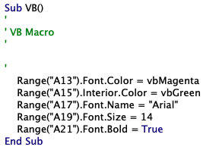

Macro code (Google Sheets):
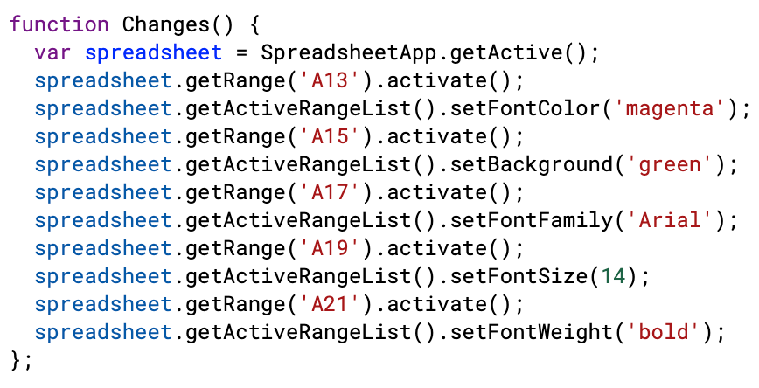
Spreadsheet when the macro has been run (Excel and Google Sheets):
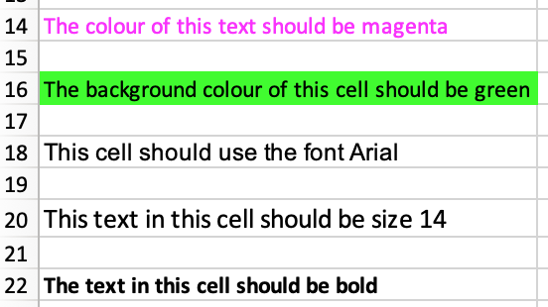

Extension activity: Ask students to complete Activity 3.2: Editing macros (Part 2) (Excel workbook 3, sheet 2/Excel workbook 3.2; Google Sheets workbook 3, sheet 2/Google Sheets workbook 3.2.)
To return the sheet to its original formatting all of the values need to be reset to their original values, which are:
- Font colour: black
- Background colour: white
- Font: Calibri
- Text size: 12
- Bold: False (Excel) /null (Google sheets)
Answer
Macro code (Microsoft Excel):
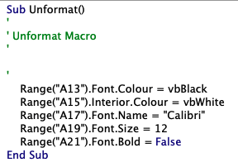

Macro code (Google Sheets):
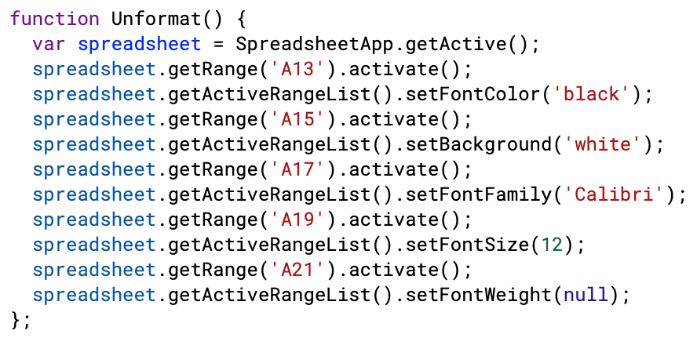

Plenary
Check students' knowledge and understanding with a short question and answer session linked to the learning objectives for the lesson.
- Why would you use a macro in a spreadsheet?
(Example answer: To automate frequently performed tasks.)
- What programming language does an Excel spreadsheet use to record and save macros? (Answer: Visual Basic) / What programming language does a Google Sheets spreadsheet use to record and save macros? (Answer: JavaScript)
- How do you run a macro?
(Example answer: You assign it to a button which can be clicked to run the macro.)
- Identify one aspect of formatting that you know how to change using Visual Basic (Excel) /JavaScript (Google Sheets) code.
(Example answer: text colour, text size, font, background colour, bold)
Homework
Ask students to complete any activities they did not finish during the lesson.
Ask students to complete Quiz 3 (Slide 19).
Stretch activities
Students who complete the activities in this lesson quickly could be encouraged to experiment with making further changes to the formatting in Activity 3.2. This could include making text Italic or using strikethrough. They may find it helpful to record another macro incorporating these formatting features, and then viewing the code to understand the commands used.
Support activities
Some students may struggle to record a macro correctly. They may benefit from writing down in order the tasks that need to be completed when the macro is recorded, and then follow this when recording their macro. This should help to ensure that they include all of the necessary steps and actions.
A number of short and informative videos can be found online that demonstrate how to record macros in Excel, such as https://www.youtube.com/watch?v=kBpTdYSh_uo.
Further tutorials and information about JavaScript can be found at https://www.w3schools.com/js/default.asp

